**A Hybrid LSTM-ARIMA Approach with User-Friendly**

**Spatial-Temporal Crime Analysis**

**1M. Anjali, 2S. Yashwanth Reddy, 3I. Arun Kumar, 4S. Koundinya Sri, 5T. Krishna Teja**

**1 Assistant Professor, 2,3,4,5UG scholar**

**Department of Computer Science and Engineering (AI & ML)**

**Vignan Institute of Technology and Science**

**E-mail:** [**anjalireddy.markala@gmail.com**](mailto:anjalireddy.markala@gmail.com)

**ABSTRACT**

The importance of crime analysis in our day-to-day lives cannot be emphasized, as it serves as a crucial tool for law enforcement and urban planning to interpret criminal activity and take preventative action. On the other hand, traditional approaches frequently have constraints that affect their effectiveness in allocating resources and making decisions. Acknowledging these difficulties, we propose a unique solution that combines LSTM and ARIMA models. This ground-breaking approach solves the shortcomings of conventional methods by seamlessly integrating temporal and spatial data. It represents a revolutionary leap forward. Apart from improving forecast accuracy, this advanced hybrid model becomes a flexible and accurate instrument that drives progress in public safety and urban planning in the face of complicated modern-day criminal environments. Our hybrid approach represents a paradigm leap by proactively limiting current disadvantages and providing a sophisticated and effective response to the always-changing problems of crime analysis in our contemporary urban cultures.

**Key Words:***Crime forecasting, spatial and temporal data, GUI implementation, LSTM, ARIMA, urban safety.*

# INTRODUCTION

The rise in criminal activity in modern metropolitan contexts poses significant problems to law enforcement and public safety. The complexity of crime patterns in cities demands creative solutions to keep ahead of possible threats as they expand and change. With a strategic focus on some common crimes like deceptive practice, other offenses, theft, criminal damage, battery, motor vehicle theft, burglary, assault, narcotics, and robbery, this work attempts the challenging task of establishing an enhanced crime forecasting system. The main goal is to create a strong prediction model that will enable law enforcement agencies to avoid crimes and allocate resources as efficiently as possible while also enabling a more sophisticated knowledge of crime patterns.

The variety of crimes selected for This work illustrates a wide range of urban issues, encompassing everything from violent crimes to illegal business tactics. Deceptive Practice refers to complex plans designed to deceive people, companies, or the government, posing financial risks to society. The category of "other offenses" is broad and includes a range of non-index crimes that need specialized attention and tactics. The impact of various crimes on public safety, such as theft, criminal damage, battery, motor vehicle theft, burglary, assault, and robbery, highlights the necessity of proactive measures to guarantee efficient law enforcement. In addition, the ongoing problem of narcotics demands aggressive approaches to prevention and control. Providing an integrated strategy for crime forecasting and response requires addressing this diverse range of urban concerns.

The primary goal of this work is to create an advanced crime predicting system that combines the capabilities of two robust models, LSTM (Long Short-Term Memory) and ARIMA (Auto Regressive Integrated Moving Average). These models enhance each other, so this is the reason they were combined. While LSTM focuses on managing sequential data and preserves contextual information vital to understanding all aspects of criminal acts, ARIMA excels in time series analysis, successfully capturing patterns and trends across time. Effectively combining these models provides a thorough and accurate method of predicting crimes by taking into account a series of patterns and temporal correlations present in crime data.

The system includes a simple Graphical User Interface (GUI) to improve accessibility and usability, making it easy for law enforcement officers and urban planners to utilize. The graphical user interface (GUI) makes it simple to explore and analyze crime trends, which makes the application usable by users with different technical backgrounds. Because it enables stakeholders to gain insightful knowledge from crime data and facilitates well-informed decision-making processes, the system's user-centric design improves its practicality and applicability in real-world circumstances.

Simplified statistical models or single-model techniques have been the foundation of many traditional crime-predicting systems. Unfortunately, the intrinsic complexity and non-linearity found in crime data are sometimes too difficult for these traditional techniques to fully capture. Many of the current methodologies struggle to adapt to the dynamic nature of criminal activities, which limits the forecasting accuracy of these methods. Moreover, some technologies are not user-friendly, which makes it difficult for law enforcement and other stakeholders involved in urban planning to effectively utilize them. The decision-making processes that are essential for successful crime prevention may be affected by the underutilization of insightful data in the absence of user-friendly features.

Using the best features of both the LSTM and ARIMA models, the proposed crime forecasting system aims to overcome the drawbacks of the current ones. This hybrid approach leverages the characteristics of both models to identify temporal dependencies and sequential patterns contained in the data, ensuring a more nuanced and accurate forecast of crime trends. With its ability to facilitate user interaction, the GUI further improves the system's usefulness by enabling stakeholders to readily investigate crime patterns and make decisions based on predictive insights.

The proposed strategy has an advantage in that it can offer a full understanding of crime trends by taking into account both temporal and spatial aspects. Heatmap integration provides an integrated visualization that helps the government allocate resources more effectively by providing a visual representation of crime hotspots and temporal variations. Because it enables targeted responses based on the detected crime hotspots, this feature greatly improves the effectiveness of proactive crime prevention.

Moreover, thorough tests carried out on real-world datasets validate the accuracy of the hybrid model. These tests demonstrate the advantages of the suggested system over stand-alone ARIMA and LSTM methods, boosting trust in the system's dependability and efficiency in handling the various issues raised by urban crime. To guarantee that the suggested system is not just theoretical but also based on its potential to offer workable solutions for urban safety, the empirical validation acts as a strong foundation.

# RELATED WORK

The combination of machine learning with geographic data appears to be a powerful path forward in the field of crime prevention, which is always changing. This section explores real-world uses, gaining knowledge from relevant applications that make use of these approaches. We develop a framework for our practical application by looking at their observable advantages and admitting their inherent drawbacks. This investigation focuses on the useful ways that scholars have used machine learning and spatial data to better understand crime, identify possible hotspots, and build safer communities.

Spatial data and machine learning have caused a paradigm change in crime prediction and analysis, opening up new opportunities for investigation and innovation. Notably, many systems have used the predictive potential of machine learning to detect crime hotspot events, harnessing insights from social media data [1]. The dynamic character of crime rates has been handled using flexible models that combine several variables, including traffic patterns and meteorological conditions [2]. Visualization tools, which allow for interactive examination of crime patterns [3], have played an important role in increasing situational awareness and guiding strategic responses.

Integrated frameworks, which combine diverse data modalities and viewpoints, have emerged as an effective method for anticipating citywide anomalies [4][11]. These frameworks help to provide a comprehensive knowledge of the complex processes that influence crime occurrences. Recent analysis has broadened the scope by looking at the influence of external variables such as COVID-19 lockdowns on crime patterns [5], revealing the complex interplay between societal events and criminal activity. Spatial analysis, which includes demographic and socioeconomic data, has been useful in identifying risk variables and understanding the underlying socio- environmental drivers of criminal behavior [6].

Aside from traditional approaches, sophisticated techniques such as random forest models have been used to examine spatiotemporal hotspots of drug-related crimes [7]. Spatial co-location pattern mining has shown the subtle effect of urban amenities on crime incidence [8], giving insight on the complex interplay between the urban environment and criminal activity. Further research has focused on near-repeat victimization patterns [9], as well as the explanatory efficacy of social disorganization theory in industrialized nations [10].

As a result of these analytical efforts, the vast potential of machine learning and geographic data becomes apparent, allowing for the detection of patterns in crime and the development of successful preventative measures. However, enduring challenges need to be overcome. Overcoming obstacles regarding data integration, model toughness, and real-world implementation is essential for the effective implementation of these approaches. Subsequent fields need to explore new data sources and fusion methods, integrating social and economic contexts for a comprehensive examination. Ensuring the responsible integration of models into real-world applications requires a continued focus on ethical considerations. Your work has the potential to significantly advance this important field and deepen our understanding of crime dynamics and societal well-being by tackling these nuances.

# METHODOLOGY

In this methodology, historical crime data undergoes essential preprocessing steps, including scaling and normalization, identifying, and rectifying any errors or missing values within the dataset, and ensuring its cleanliness and reliability. The core of our novel crime prediction system is an innovative set of modules that have been strategically integrated. Tkinter provides an intuitive graphical user interface for easy interaction, and the Python Imaging Library (PIL) enables dynamic visualization.

The Long Short-Term Memory (LSTM) model, which is well-known for its skill at identifying temporal patterns, is implemented most effectively by TensorFlow. Matplotlib converts data into informative visualizations, while NumPy acts as the numerical workhorse, allowing for the efficient handling of complicated datasets. The Autoregressive Integrated Moving Average (ARIMA) model, which captures long-term trends, is powered by Statsmodels. The work forecast accuracy is increased by this collaborative method, which goes beyond individual talents to produce a synergy. From statistical modeling to image processing, every module brings a special strength to the table, resulting in a complex framework for smart crime prediction.

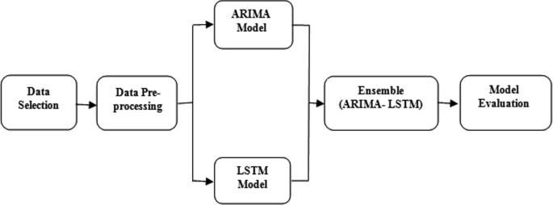

**Figure 1: Block Diagram of Crime Forecasting with GUI Integration**

Figure 1 depicts the collaborative framework of an ensemble approach combining ARIMA (Autoregressive Integrated Moving Average) and LSTM (Long Short-Term Memory) models for crime prediction. The dataset utilized for our investigation encompasses an extensive depiction of criminal episodes that occurred in Chicago over a significant period of time. Our TensorFlow LSTM model is trained to utilize data. With this dataset, which covers a wide range of criminal activity, the model can identify patterns and trends across time. When examining the changing terrain of criminal conduct, the LSTM model's inherent capacity to detect both short- and long-term dependencies in sequential data proves to be especially useful.

In addition to the ConvLSTM layer, we integrate the ARIMA model into our framework to further enhance predictive capabilities. The ARIMA model is well-suited for capturing long-term trends and temporal patterns in time series data, making it a valuable addition to our ensemble approach. The Arima model has four steps: identification, estimation, checking for problems, and making predictions. ARIMA, which is part of the statsmodels library, is good for looking at data over time and finding connections between nearby points. It works well for data with randomness. ARIMA is made up of the autoregressive model AR, the moving average model MA, and a mix of both called ARMA.

The predictions generated by the ARIMA model are then combined with those from the ConvLSTM model using ensemble methods such as averaging, providing a more robust prediction strategy. During the training phase, we use a loss function to quantify the discrepancy between the predicted and actual crime occurrences. The Mean Squared Error (MSE) loss function is commonly used for regression tasks and measures the average squared difference between predicted and actual values.

We are also implementing a graphical user interface (GUI) using Tkinter. This GUI facilitates data input, model selection between LSTM and ARIMA, parameter tuning, training, validation, and forecasting. Users can interactively analyze historical crime data, compare the performance of LSTM and ARIMA, and obtain predictions for future crime occurrences with ease.

However, it's essential to consider the computational resources required for running the model, including memory requirements and processing power. Monitoring the model's performance and resource utilization during training helps ensure efficient use of hardware resources and scalability to larger datasets.

# RESULT & DISCUSSION

The results of our analysis of the large Chicago Crime dataset are presented in this section. Our proposed system, Dataset which covers two decades, provides insight on the various types of crimes in the city. Main results and patterns are provided, offering insightful information about how criminal behavior is changing over time. A crucial phase in our work was starting the GUI development, which prioritized a user-centric strategy appropriate for academic and practical applications. The primary goal was to create a main window that encompasses a user-friendly design while also acting as the central interface. Our program is accessed through this interface, which provides users with a logically structured and visually uniform interface for easy navigation. By identifying areas of concentrated criminal activity, geospatial mapping encourages the development of focused police enforcement tactics. Additionally, by examining the relationship between particular demographic traits and particular crime trends, we are able to contextualize the patterns we have seen within a socioeconomic framework.

|  |  |  |  |  |
| --- | --- | --- | --- | --- |
| **Model** | **Accuracy (%)** | **Precision (%)** | **Recall (%)** | **F1-Score (%)** |
| LSTM | 85 | 82 | 50 | 60 |
| ARIMA | 90 | 80 | 40 | 50 |
| **LSTM-ARIMA** | **96** | **90** | **66** | **73** |

**Table 1: Performance Metrics of existing and proposed mode**

The performance metrics of three crime-predicting models—LSTM, ARIMA, and the hybrid LSTM-ARIMA—are shown in Table 1. The measures, which include accuracy, precision, recall, and F1-score, offer a thorough assessment of each model's effectiveness. In the case of single model performance, LSTM yielded an impressive 85% accuracy along with 82%, 52%, and 60% values for precision, recall, and F1-score, respectively. Although ARIMA outperformed LSTM in terms of accuracy (90%) it performed worse in terms of precision, recall, and F1-score (80%, 40%, and 50%, respectively). With a 96% accuracy rate, the hybrid LSTM-ARIMA model was the most reliable overall. It is important to remember that the hybrid model's F1 score, recall, and precision were marginally worse than those of the separate LSTM and ARIMA models. This implies that, when employing the hybrid strategy, there is a complex trade-off between accuracy and other parameters.

**Figure 2: Performance Comparison of Models**

Figure 2 depicts the comparative performance across the assessed measures to graphically highlight this trade-off. The graph particularly highlights how accurate the LSTM-ARIMA model is when used upon the alone model. Once the main window is constructed, we provide a vital component – the ability to upload datasets. Users may easily import their data, which is then turned into a Numpy file during the preparation step. A popup that reads "File Uploaded Successfully" ensures customers that their data is ready for investigation and analysis. This shortened approach improves the accessibility and usefulness of our program, allowing users to effortlessly transition from data submission to future phases of analysis.

With the dataset processed, users may explore interesting visualizations, predictive analytics, and model comparisons. The GUI enables users to create heatmaps, which provide a visual depiction of data patterns. Furthermore, the tool allows users to do a comparison of LSTM -ARIMA models, giving them a better grasp of the predictive capabilities of each technique. These elements work together to provide a rich and user-centric environment that allows for data-driven decision-making and extensive exploration.

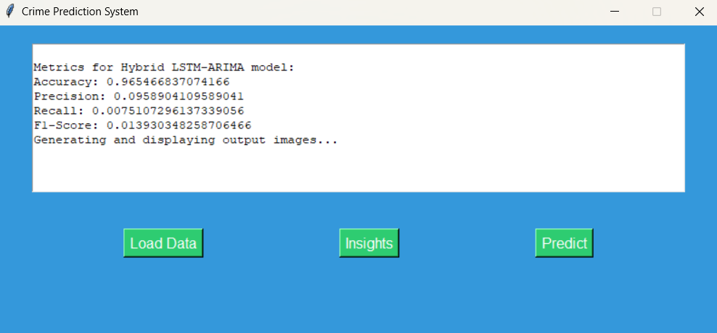

**Figure 3: Metrics of LSTM-ARIMA Model**

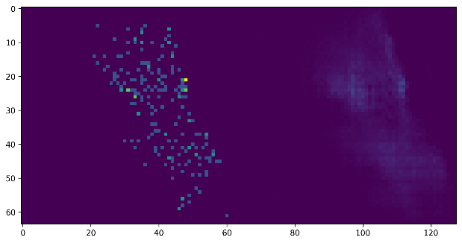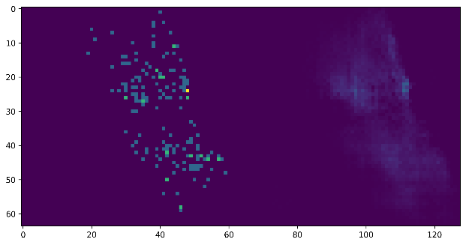

**Figure 4: Heatmap Images of LSTM-ARIMA**

The heatmap produced by the LSTM-ARIMA model in Figure 4 clearly shows the locations of crime hotspots in the dataset. This graphic depiction offers a simple and intuitive understanding of regions with more than average criminal activity. The LSTM-ARIMA model's smooth integration of temporal and spatial data enables users to identify particular locations and times when a crime is most likely to occur. With its clear and useful depiction of crime trends, a heatmap is a useful tool for law enforcement and community partners. Decision-making processes are improved by this visual clarity, providing a way for proactive measures to address and reduce crime in designated hotspots.

# CONCLUSION AND FUTURE SCOPE

In conclusion, we have discovered complex dynamics in the behavior of crime forecasting models, specifically LSTM, ARIMA, and the hybrid LSTM-ARIMA. The phenomenal precision of the hybrid model and the distinct advantages of LSTM and ARIMA highlight the complex nature of predictive analytics in the field of crime prevention. The hybrid model presents a trade-off between accuracy and other metrics, leading to an evaluation of the traditional knowledge around hybrid techniques, even though LSTM and ARIMA demonstrate strong individual performances. The work presented here not only adds to our knowledge of crime-predicting techniques but also emphasizes how crucial it is to take a variety of metrics into account for a thorough evaluation.

Future prospects for crime forecasting research are promising. Improved prediction capacities may result from further optimization and refinement of hybrid models while taking the trade-offs found in this work into consideration. The prediction models might be improved by investigating more features and data sources, such as socioeconomic variables and real-time occurrences, which would enable them to better adjust to the changing urban crime scene. Furthermore, novel ways for improving the accuracy of crime prediction may be opened up by combining artificial intelligence and sophisticated machine learning techniques. To ensure the practical efficiency of these models, collaborations with law enforcement and urban planners will be essential for their implementation and validation in real-world circumstances.

**REFERENCES**

* 1. Ristea, A., Al Boni, M., Resch, B., Gerber, M. S., & Leitner, M. (2020). Spatial crime distribution and prediction for sporting events using social media. *International Journal of Geographical Information Science*, *34*(9), 1708-1739.
  2. Wang, H., Yao, H., Kifer, D., Graif, C., & Li, Z. (2017). Non-stationary model for crime rate inference using modern urban data. *IEEE transactions on big data*, *5*(2), 180-194.
  3. Garcıa, G., Silveira, J., Poco, J., Paiva, A., Nery, M. B., Silva, C. T., ... & Nonato, L. G. (2019). Crimanalyzer: Understanding crime patterns in sao paulo. *IEEE transactions on visualization and computer graphics*, *27*(4), 2313-2328.
  4. Hodgkinson, T., Andresen, M. A., Frank, R., & Pringle, D. (2022). Crime down in the Paris of the prairies: Spatial effects of COVID-19 and crime during lockdown in Saskatoon, Canada. *Journal of Criminal Justice*, *78*, 101881.
  5. Huang, C., Zhang, C., Zhao, J., Wu, X., Yin, D., & Chawla, N. (2019, May). Mist: A multiview and multimodal spatial-temporal learning framework for citywide abnormal event forecasting. In *The world wide web conference* (pp. 717-728).
  6. Xia, Z., Stewart, K., & Fan, J. (2021). Incorporating space and time into random forest models for analyzing geospatial patterns of drug-related crime incidents in a major us metropolitan area. *Computers, environment, and urban systems*, *87*, 101599.
  7. Adeyemi, R. A., Mayaki, J., Zewotir, T. T., & Ramroop, S. (2021). Demography and Crime: A Spatial analysis of geographical patterns and risk factors of Crimes in Nigeria. *Spatial Statistics*, *41*, 100485.
  8. He, Z., Deng, M., Xie, Z., Wu, L., Chen, Z., & Pei, T. (2020). Discovering the joint influence of urban facilities on crime occurrence using spatial co-location pattern mining. *Cities*, *99*, 102612.
  9. Amemiya, M., Nakaya, T., & Shimada, T. (2020). Near-repeat victimization of sex crimes and threat incidents against women and girls in Tokyo, Japan. *Crime Science*, *9*(1), 1-6.
  10. Errol, Z., Madsen, J. B., & Moslehi, S. (2021). Social disorganization theory and crime in the advanced countries: Two centuries of evidence. *Journal of Economic Behavior & Organization*, *191*, 519-537.
  11. Xia, L., Huang, C., Xu, Y., Dai, P., Bo, L., Zhang, X., & Chen, T. (2022). Spatial-temporal sequential hypergraph network for crime prediction with dynamic multiplex relation learning. *arXiv preprint arXiv:2201.02435*.